**IT TICKETS SUPPORT SYSTEM ANALYSIS**

**1. OBJECTIVE QUESTIONS:**

**1.1** What is the total no. of attributes present in the data?

ANS: My dataset ‘IT TICKET ANALYSIS’ have two sheets namely ‘TICKETS’ and ‘IT AGENTS’ which have 10 and 6 attributes respectively. As Agent_id is repeated in both of them, total attributes given originally in the dataset is 15.

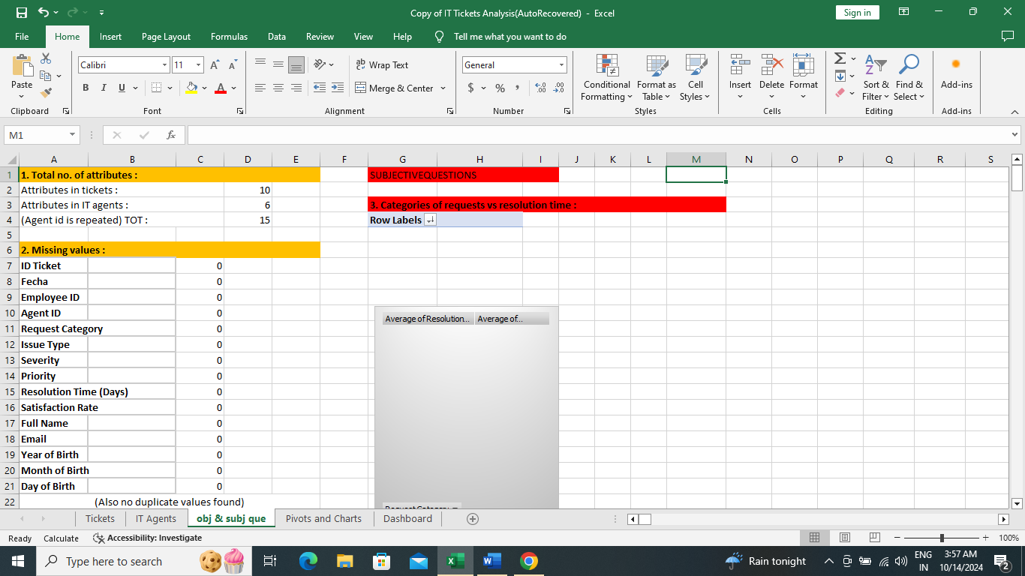

**1.2** Which columns have inconsistent or missing values, and what is the count of such values?

ANS: There were no missing values in my data set. Some of the inconsistent values are replaced in columns ‘priority’ and ‘severity’.

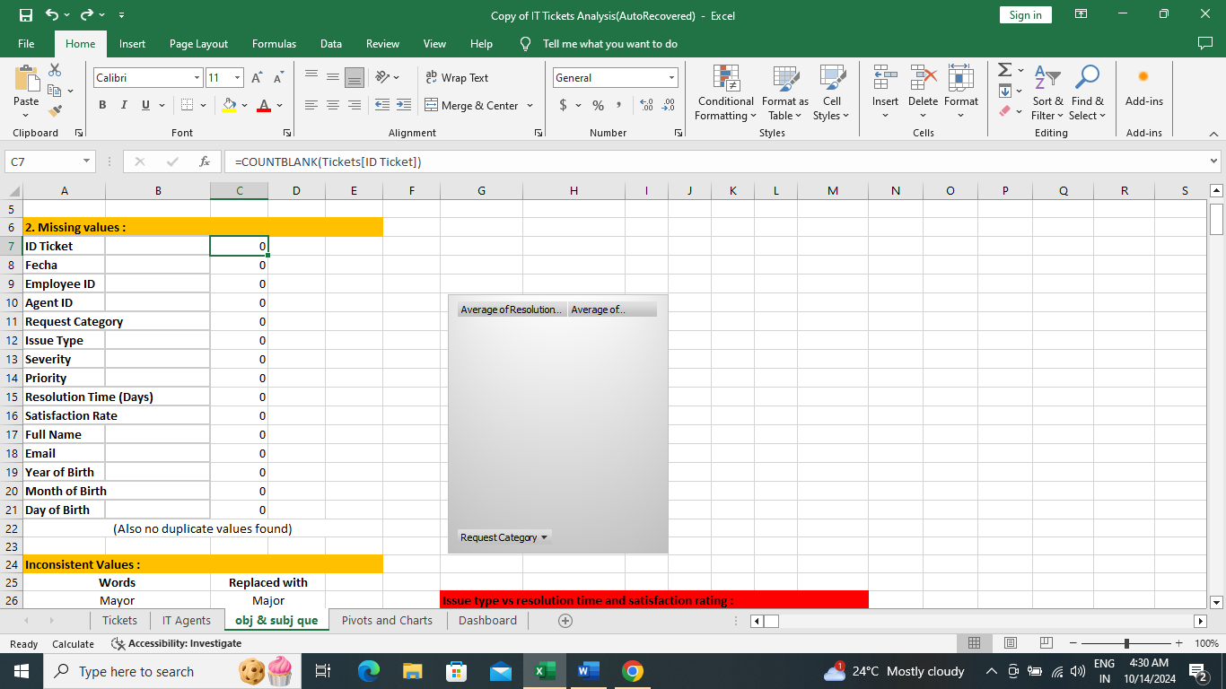

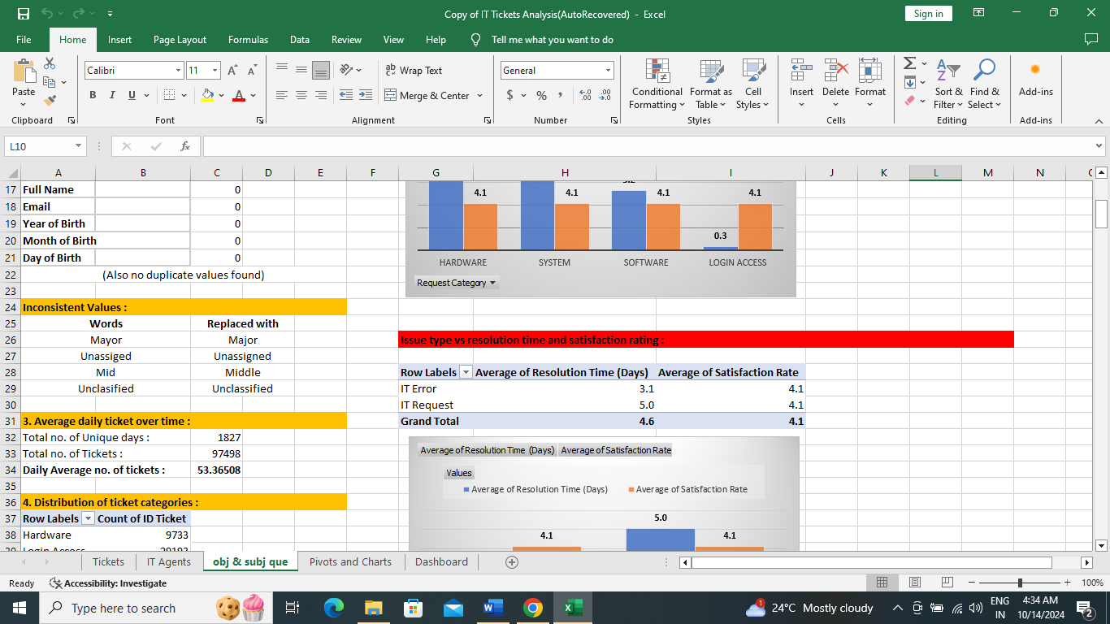

**1.3** What is the average daily ticket volume over time?

ANS: Average daily tickets can be calculated by pivot table, but it can also be calculated by dividing total number of tickets by number of unique days. Unique days are calculated by flagging Dates (Fecha) as ‘Unique’ or ‘Duplicate’ and then counting ‘Unique’ values in the flagged column, so the number of average daily tickets is 53.36.

Formula to flag Unique/Duplicate: =IF(COUNTIF(B$2:B2,B2)=1,"Unique","Duplicate")

Formula to count ‘unique’ values: =COUNTIF(Tickets[Unique/Duplicate],"Unique")

Formula to count Total Tickets: =COUNTA(Tickets[ID Ticket])

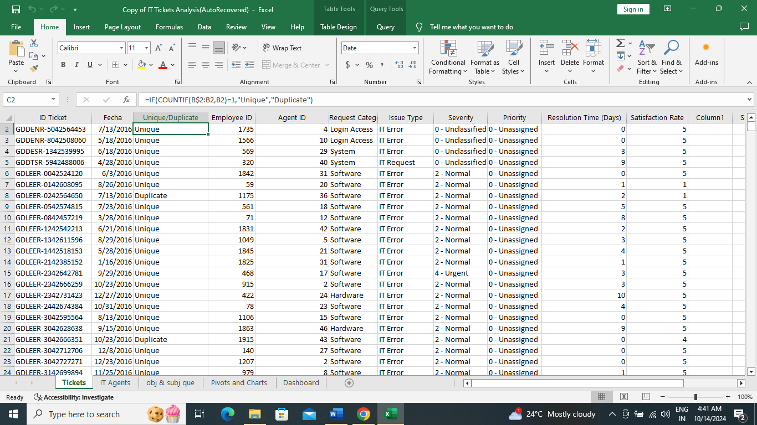

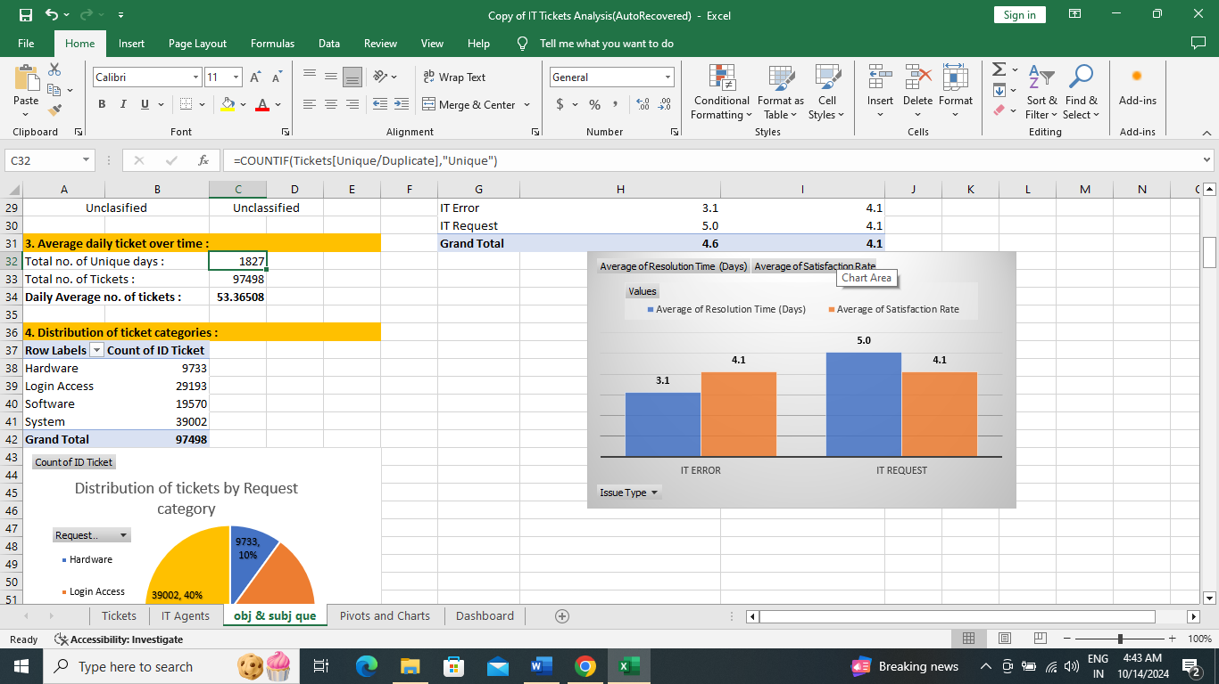

**1.4** What is the distribution of ticket categories (e.g., Login Access, System, Software)?

ANS: It can be calculated by pivot table and a pie chart, Hardware has highest share of 40%.

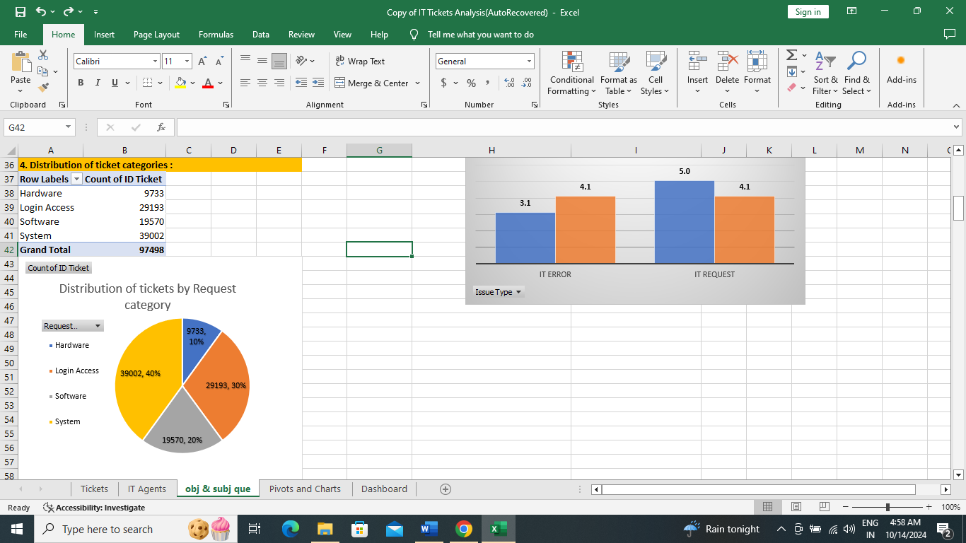

**1.5** How many tickets has each agent handled?

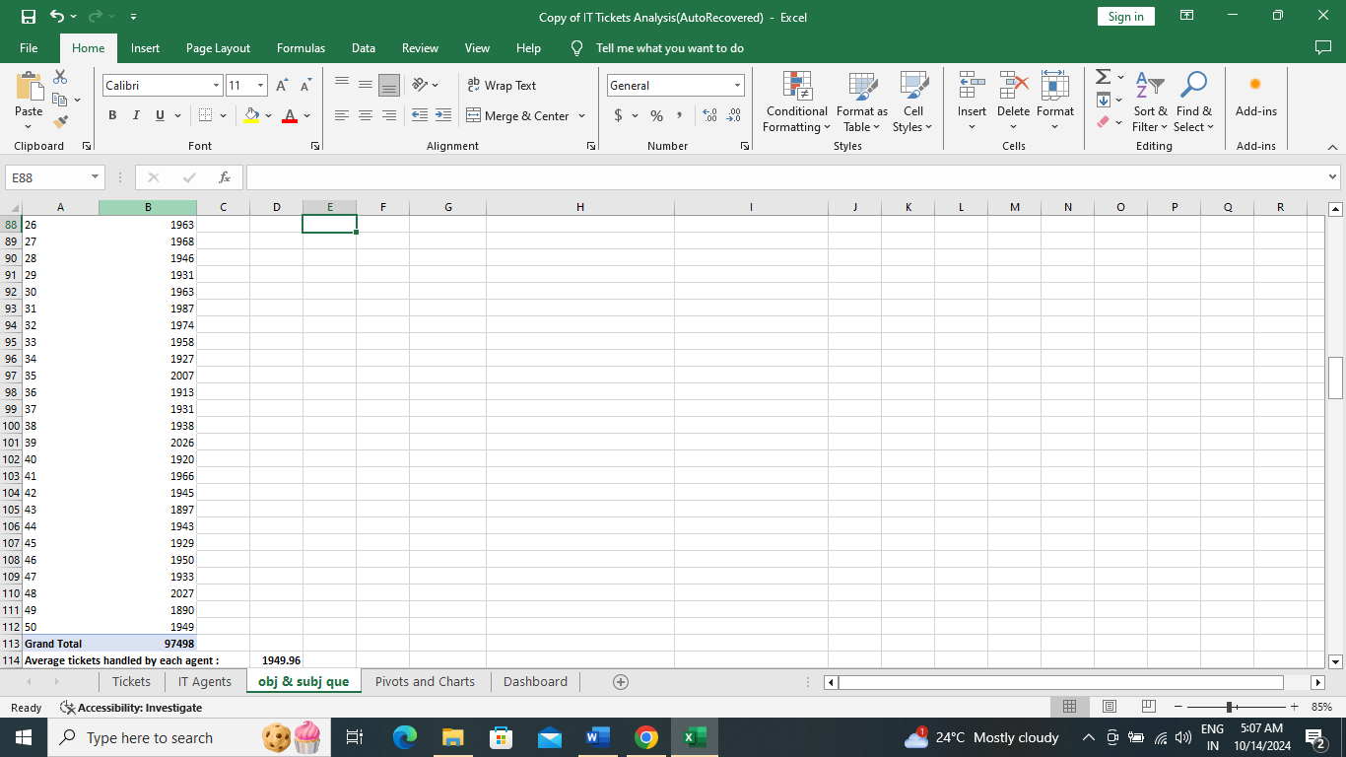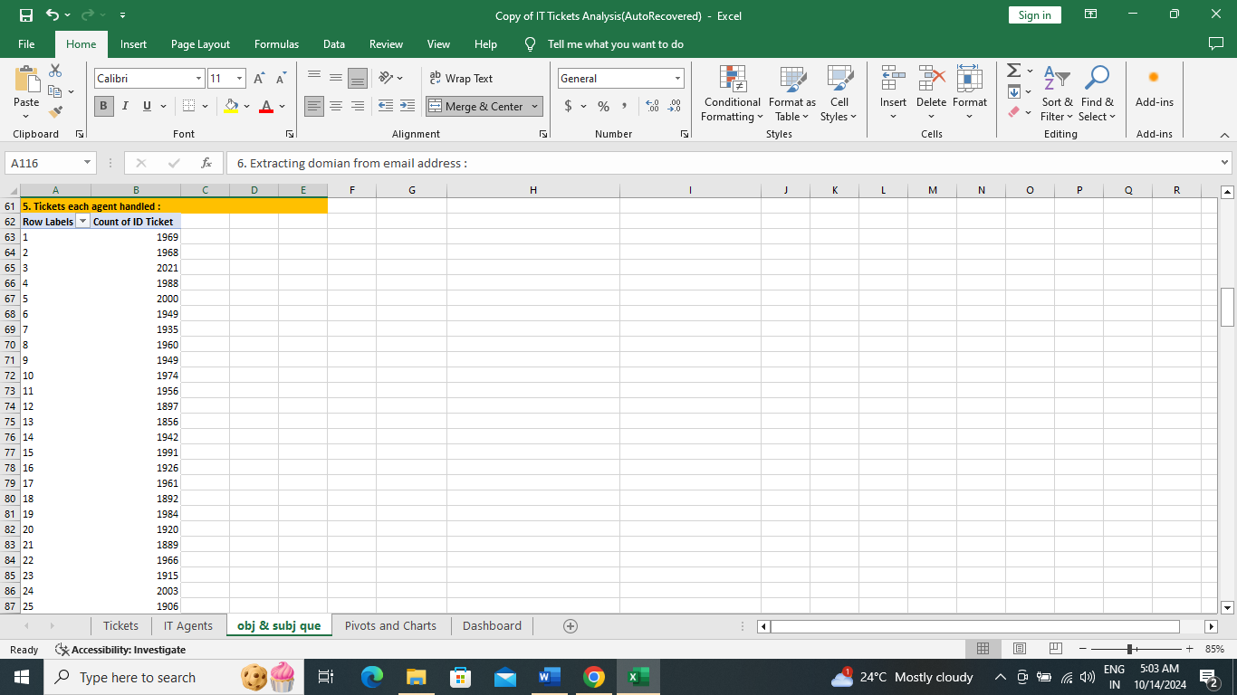ANS: On an average each agent handled 1949 tickets. It can be calculated by total tickets/number of agents.

**1.6** How can you extract the domain from the email addresses in the IT Agents sheet?

ANS: Domain name can be extracted from email addresses by combination of Right and Left function. Formula used is: =LEFT(RIGHT(A118,LEN(A118)-FIND("@",A118)),FIND(".",RIGHT(A118,LEN(A118)-FIND("@",A118)))-1)

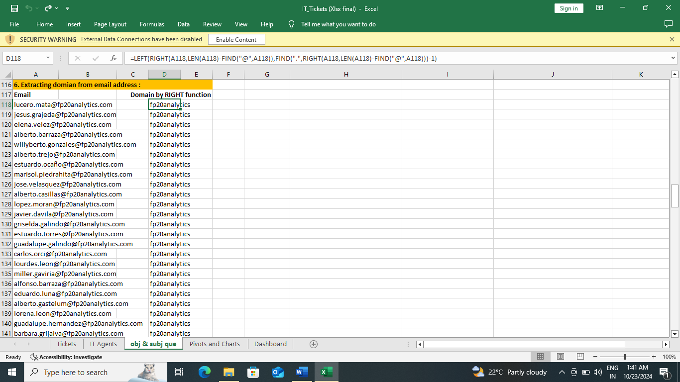

**1.7** How can you find the full name of an agent given their Agent ID?

ANS: Full name through agent ID can be retrieved by Vlookup, Xlookup and ssIndex&match functions.

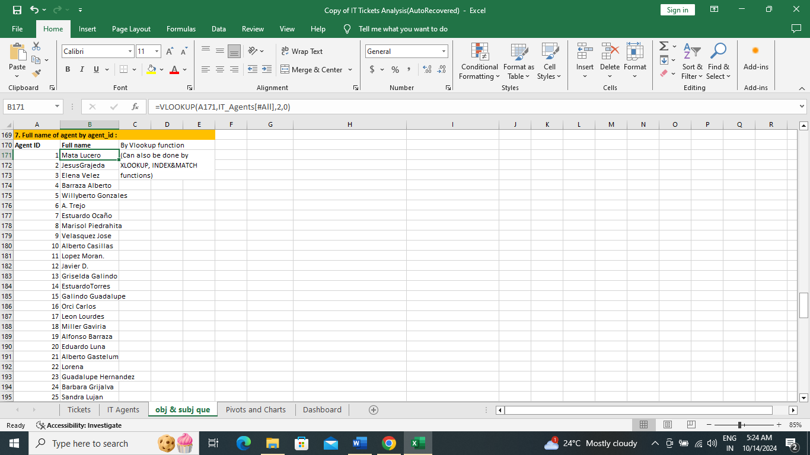

**1.8** What is the count of each issue type (e.g., IT Error, IT Request)?

ANS: It can be calculated by pivot table. Count of IT Error and IT Request are 24278 and 73220 respectively.

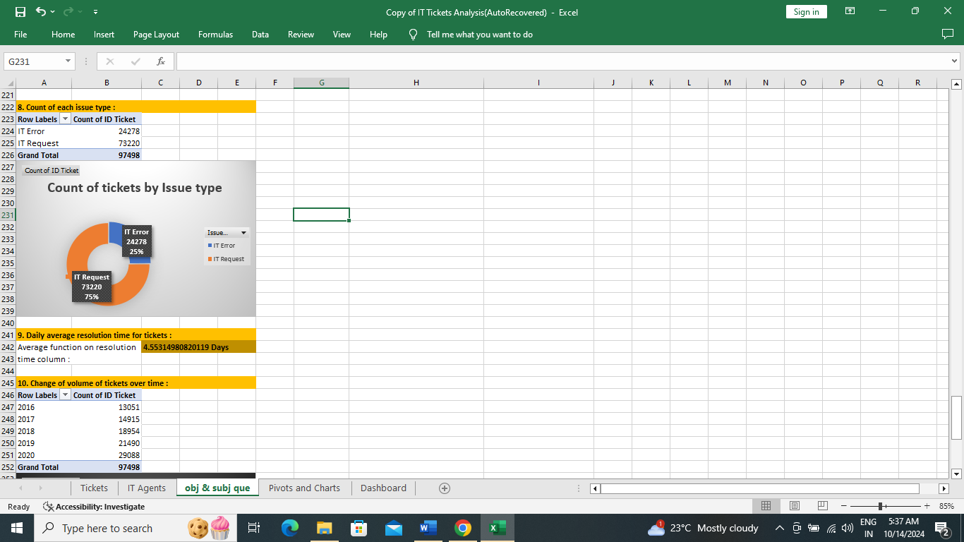

**1.9** What is the daily average resolution time for tickets?

ANS: By using average function on ‘Resolution Time(Days)’ column, it is 4.5 Days.

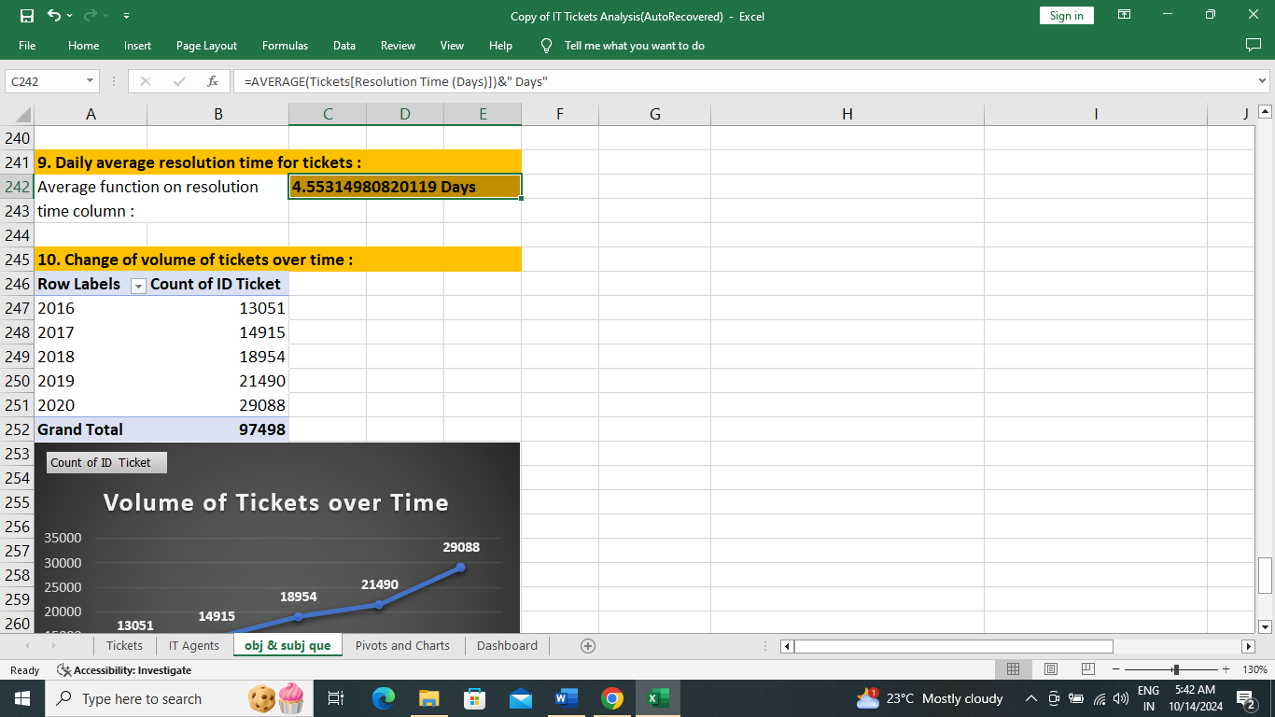

**1.10** How has the volume of tickets changed over time?

ANS: Volume of tickets has increased over time from 2016 to 2020.

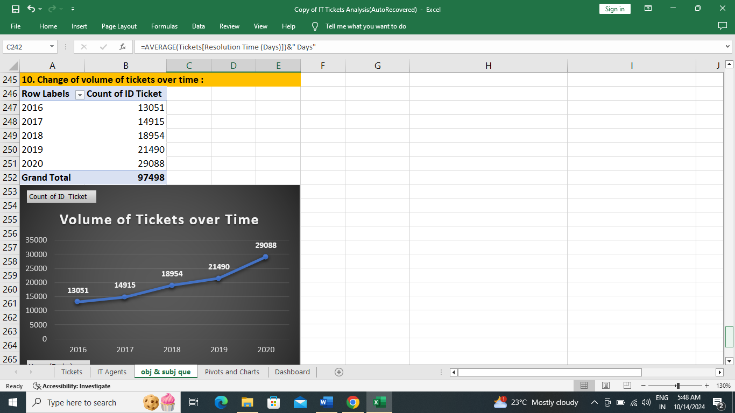

**1.11** What is the average age of the IT agents?

ANS: Age of each IT agent is calculated by ‘=datedif(DOB,TODAY(),”Y”)’ and then average age is calculated by average function. Average age of ITAgent is 39.18 Years.

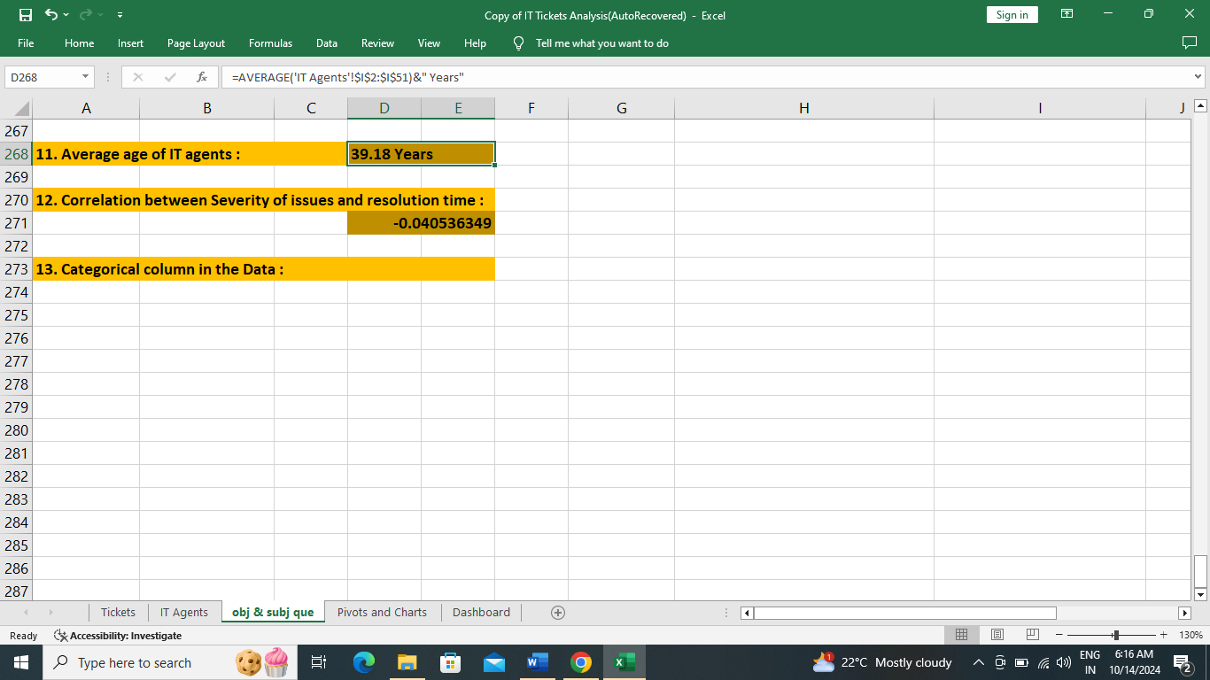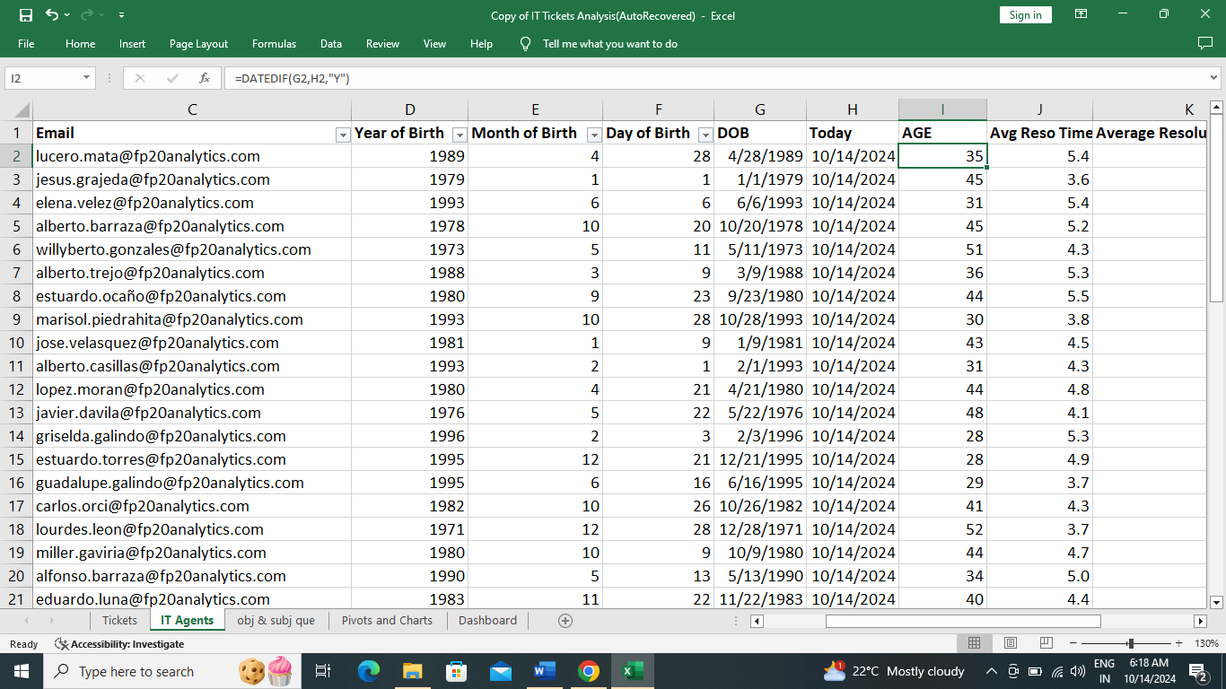

**1.12** Is there a correlation between the severity of issues and the resolution time?

ANS: Correlation between Severity of issues and Resolution time can be calculated by first applying text to column function on Severity column to separate severity_type and severity_number and then correl function is applied on severity_number and resolution time. Its value is -0.040536349. That means there is no strong correlation between them as the value is not near to -1 or +1.

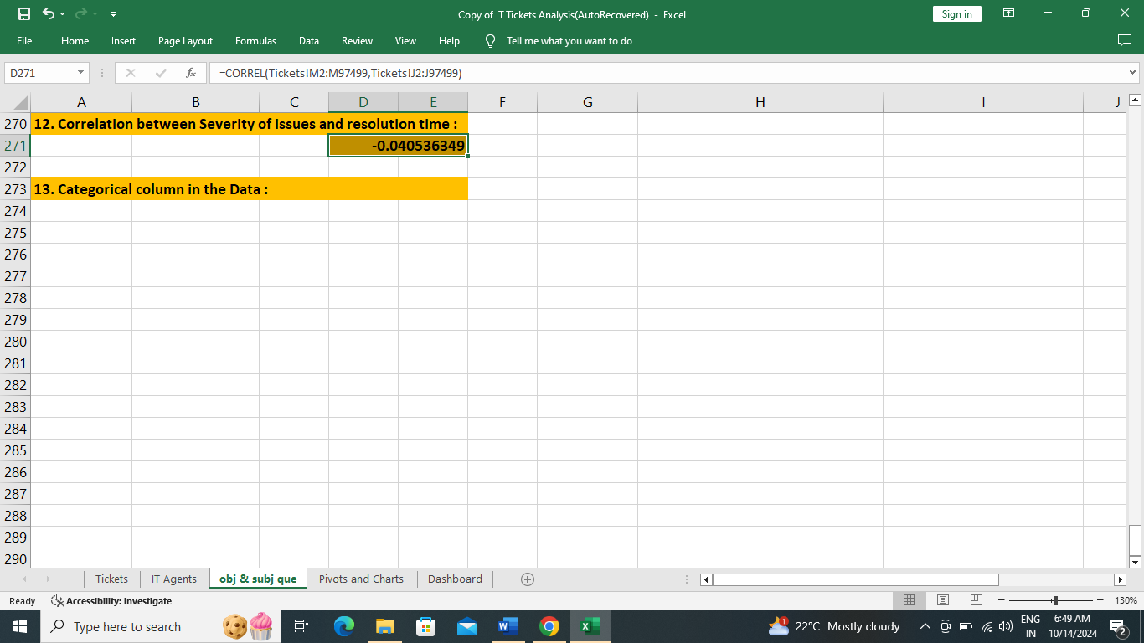

**1.13** How many categorical columns are there in the data? [Search about categorical and continuous data, and try to answer this question]

ANS: Categorical data means that they represent certain category or groups rather than a single item. Example: Race, sex etcetera. In my dataset ‘IT TICKET ANALYSIS’ there are four Categorical columns namely: Request_Category, Issue_Type, Severity, Priority.

**2. SUBJECTIVE QUESTIONS:**

**2.1** If there is an investment, should it be used to hire more IT agents, improve training programs, or upgrade ticket management software? (Analysis: Perform a cost-benefit analysis using ticket resolution and satisfaction metrics.)

ANS:

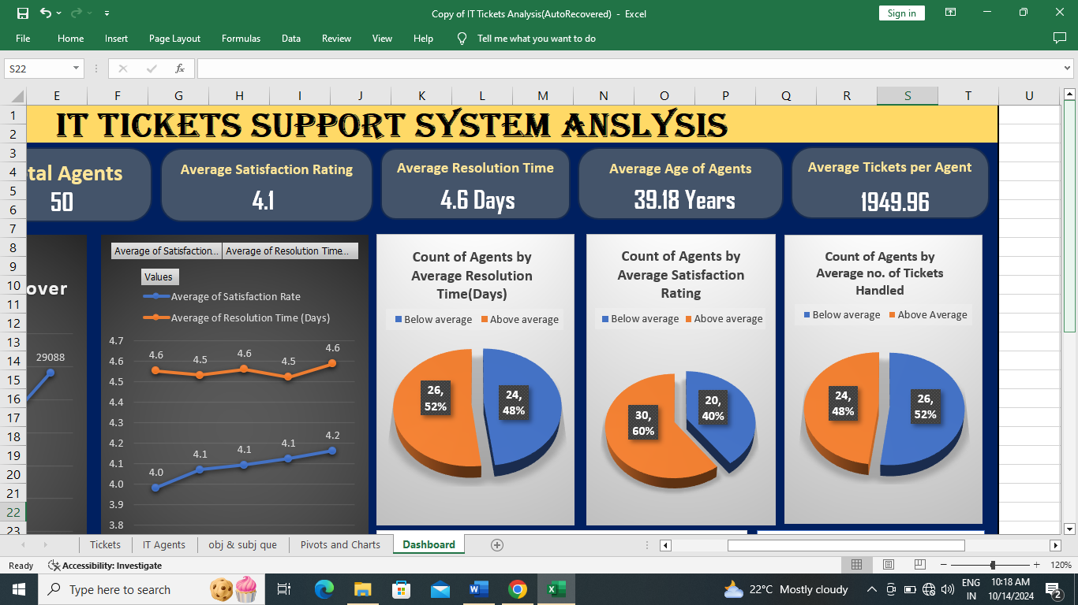

**Data Insights:**

1. 48% (24) of Agents are below average (4.6 days), if Resolution time(days) is considered.

2. 40% (20) of Agents are below average (4.1), if Satisfaction Rating is considered.

3. 52% (26) of Agents are below average (1949 tickets per agent), if tickets handled per agent is considered.

**Recommendations:**

**1. First priority for investment is Training:** As seen from data, IT support team is not performing at its full potential. There is an ample room for training. **Benefit:** It needs less investment compared to hiring and implementing new tools. **Cost:** Victimization of agents has to be prevented.

**2. Second priority for investment is Hiring:**  **Benefit**: It may further increase the satisfaction rating and reduce resolution time also. Team can handle further increase of tickets volume. **Cost:** More investment needs for onboarding a new Employee and still Team may not work at its full potential.

**3. Third priority for investment is upgrade Ticket management software: Benefit:** It will be an asset for the Team and can handle future issues like surge of tickets. **Cost:** Huge investment burden.

**2.2** Which agents need additional training based on their performance metrics? (Analysis: Identify agents with the lowest satisfaction ratings and longest resolution times.)

ANS:

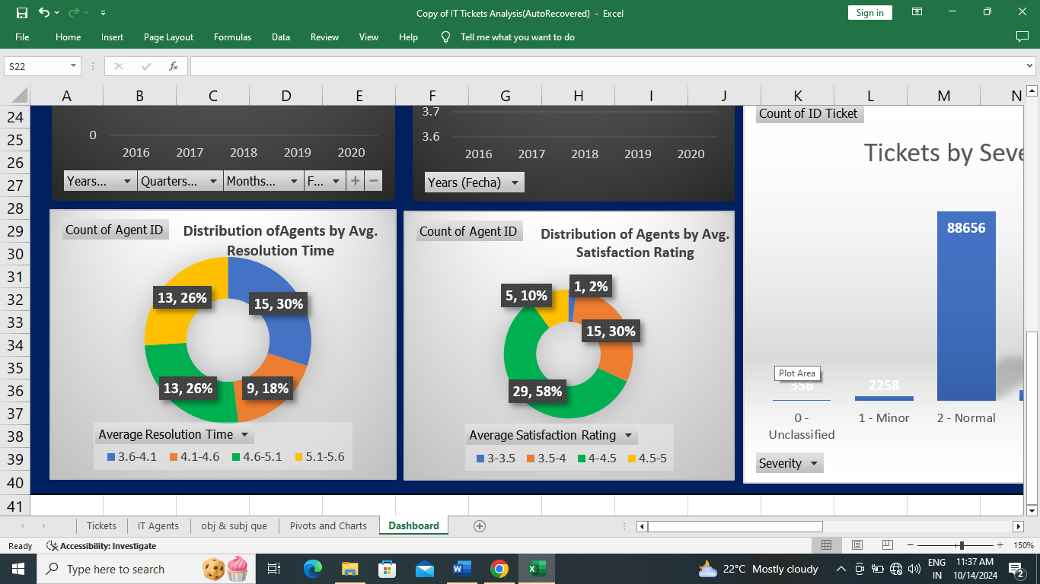

**Recommendation:**

1. Highest band for average resolution time(days) is 5.1-5.6 days. These must be trained in first priority if we are going by average resolution time.

2. Lowest band for satisfaction rating is 3-4. These must be trained in first priority if we are going by average satisfaction rating.

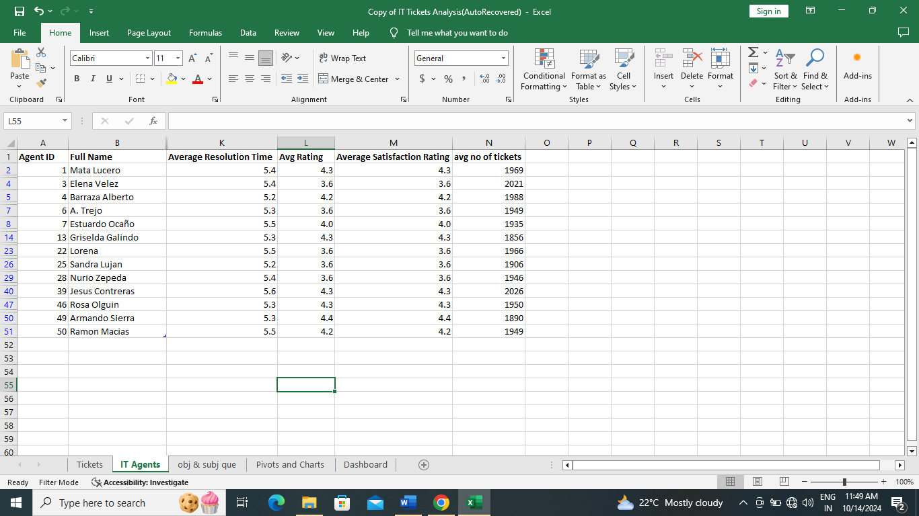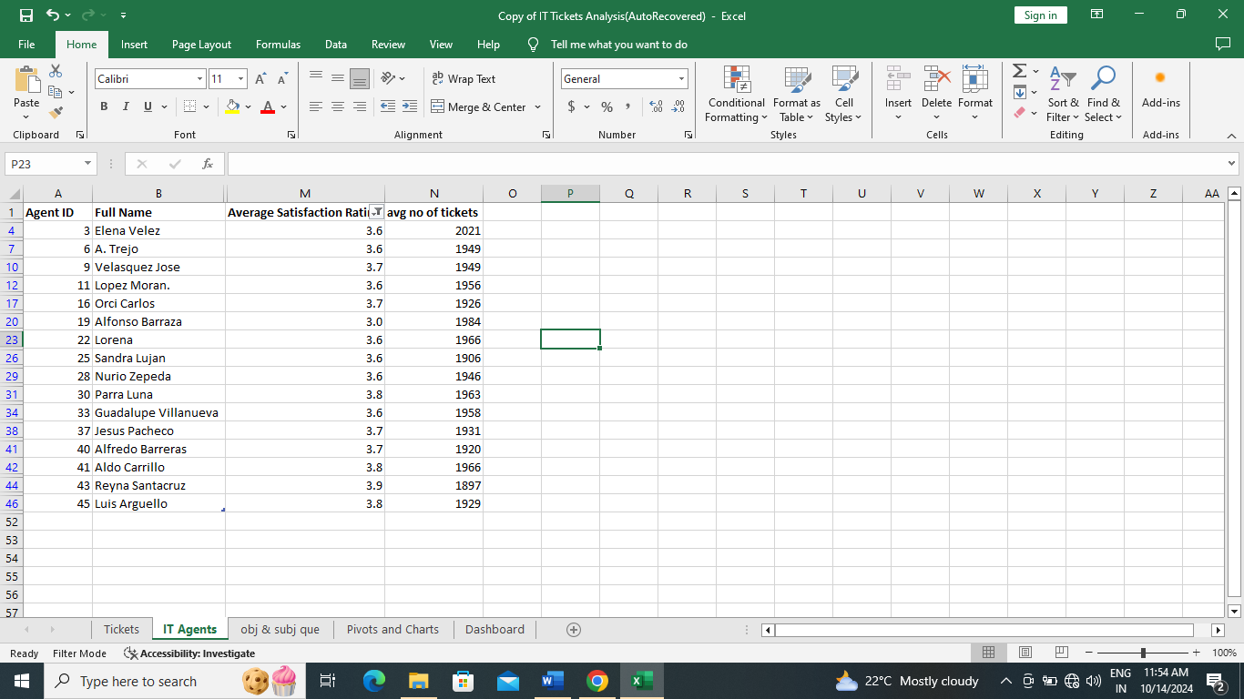

**2.3** Do certain categories of requests have longer resolution times?(Analysis: Analyze the resolution times by request category.)

ANS:

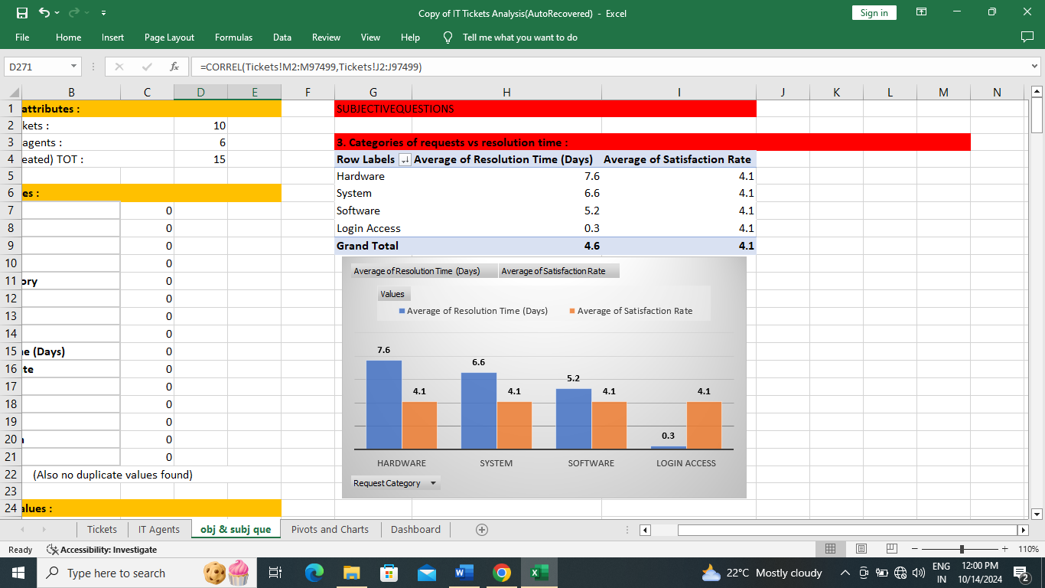

**Data Insights:** Despite satisfaction rate remaining constant for all request categories, average resolution time is more for ‘hardware’ request category followed by ‘system’ and then by ‘software’.

**2.4** How effective are the current software tools in managing IT tickets? (Analysis: Evaluate performance metrics before and after the implementation of new tools.)

ANS:

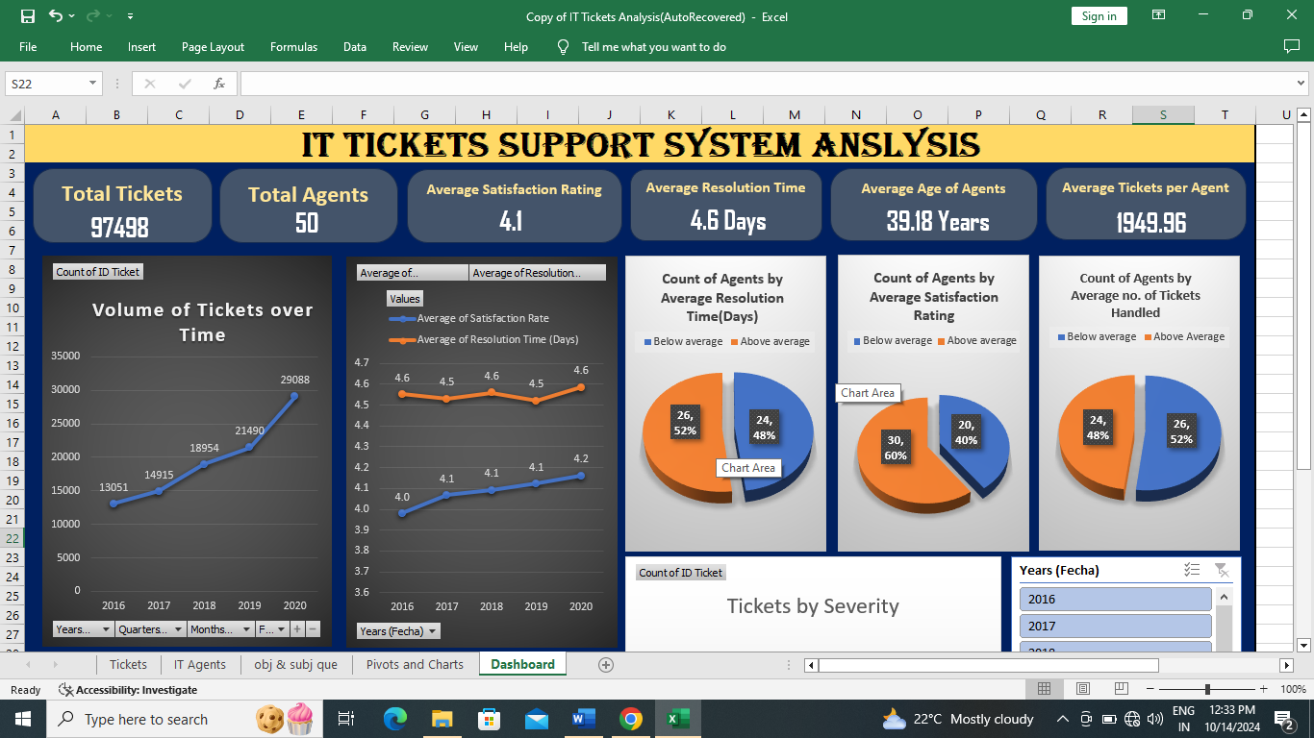

**Data Insights:**

The Current software tools have performed good. From the first graph it is evident that there is a surge in number of tickets, but our system has handled it better despite a slight increase in resolution time. Increase in average satisfaction rate is commendable.

**Recommendation:**

As said earlier training, hiring or upgrading software tools are solutions in first, second and third priority respectively.

**2.5** How has the performance of the IT support team changed over time (e.g., monthly or quarterly)? (Analysis: Trend analysis using time series charts.)

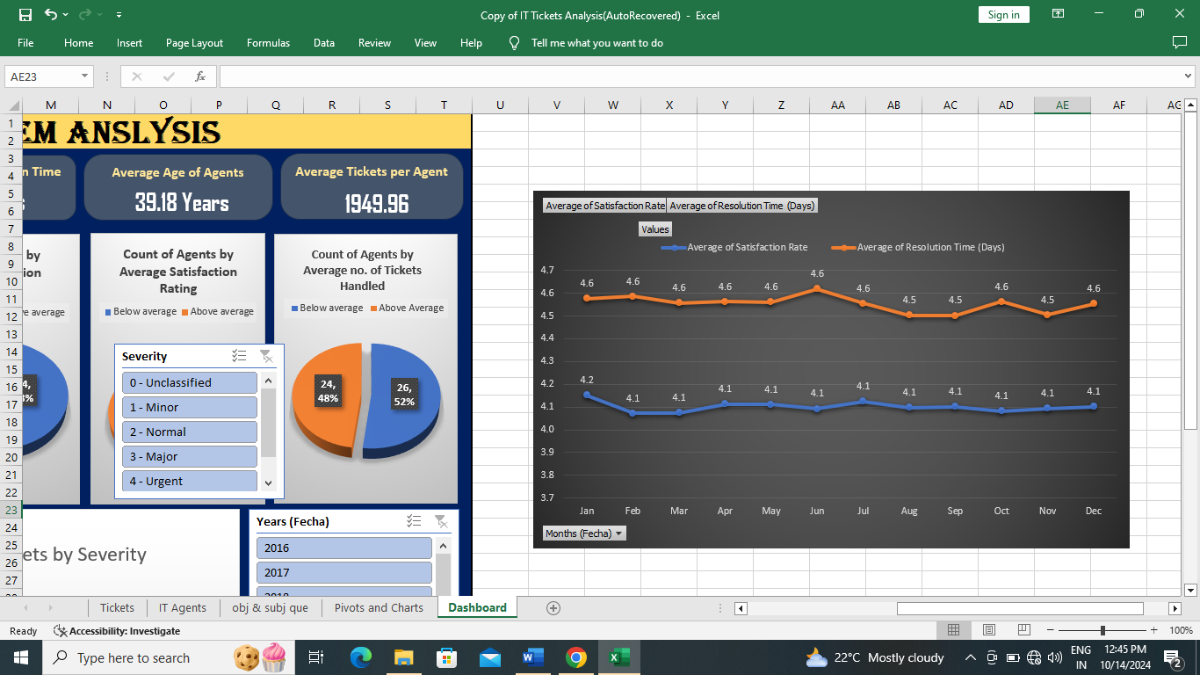ANS:

If trend is analyzed monthly wise:

Resolution time was high during JUNE, OCTOBER and DECEMBER and almost stagnant in rest of the months.

Satisfaction rate was almost stagnant at 4.1 throughout all months.

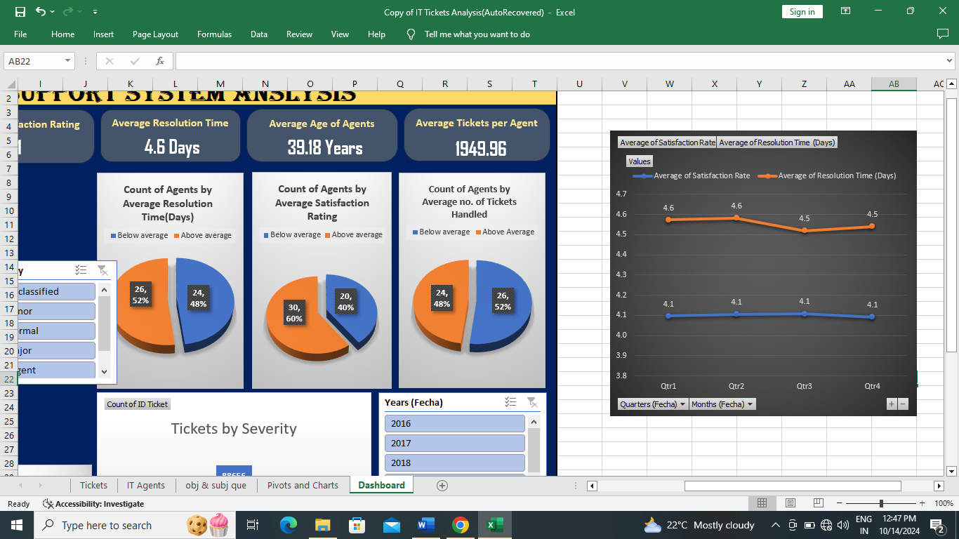

If trend is analyzed quarter wise:

Resolution time was high during first two quarters.

Satisfaction rate is almost constant at 4.1.

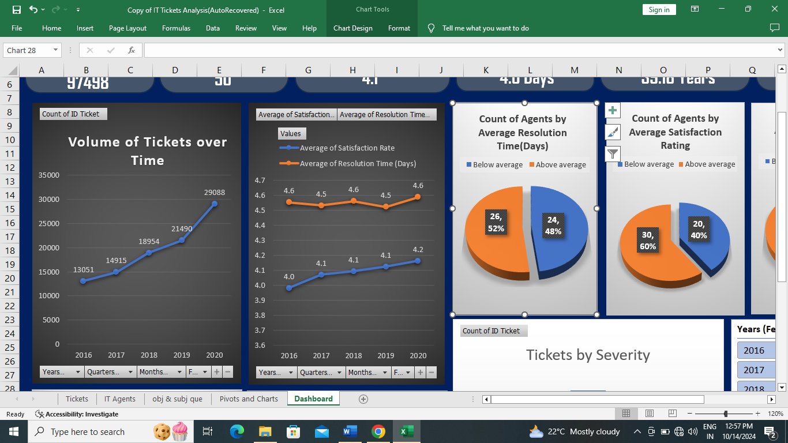

If trend is analyzed yearly wise:

Resolution time is high during 2016, 2018, 2020.

Satisfaction rate has increased in 2017 and 2020. Its trend from 2016 is commendable.

**2.6** If we invest more on tech (Hardware, software, etc.) do you think it will improve the ticket resolution times and employee satisfaction? (Analysis: Use historical data to project potential improvements)

ANS:



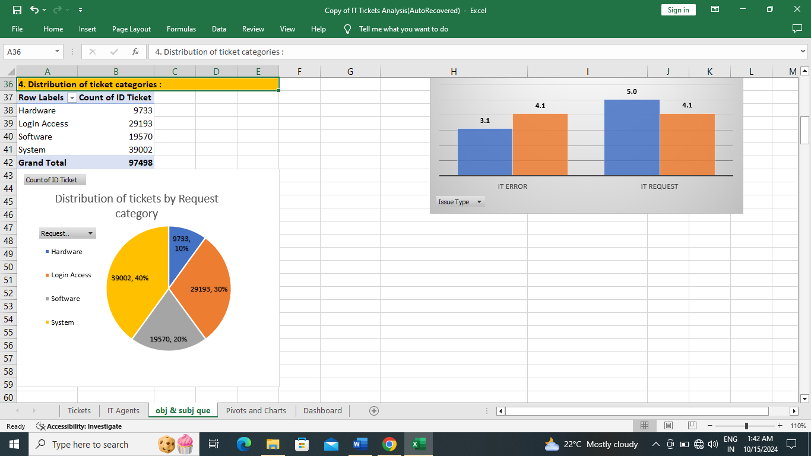

**Data Insights:**

1. 30% of volume of tickets belong to hardware and Software.

2. Resolution time for hardware is highest (7.6 days) and for software (5.2 days) also it is high (though it is comparatively less than system (6.2 days) and hardware).

3. Satisfaction rate is almost stagnant and same for all categories of requests.

**Recommendation:**

Yes, investment in ‘hardware’ and ‘software’ will improve employee satisfaction rate and reduce resolution time. But ‘System’ request category has more resolution time than software, so investing in ‘hardware’ and ‘system’ would be best option than hardware and software.

**2.7** What are the key performance metrics for IT agents, and how can they be improved, do we need to fire any agents? (Analysis: Define and analyze metrics such as average handling time, satisfaction scores, and number of tickets resolved.)

ANS:

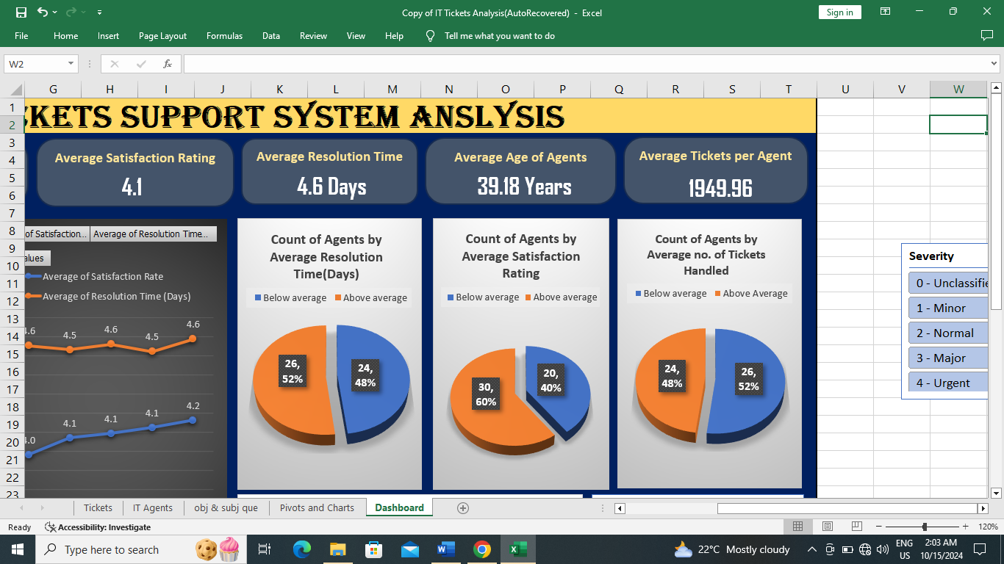

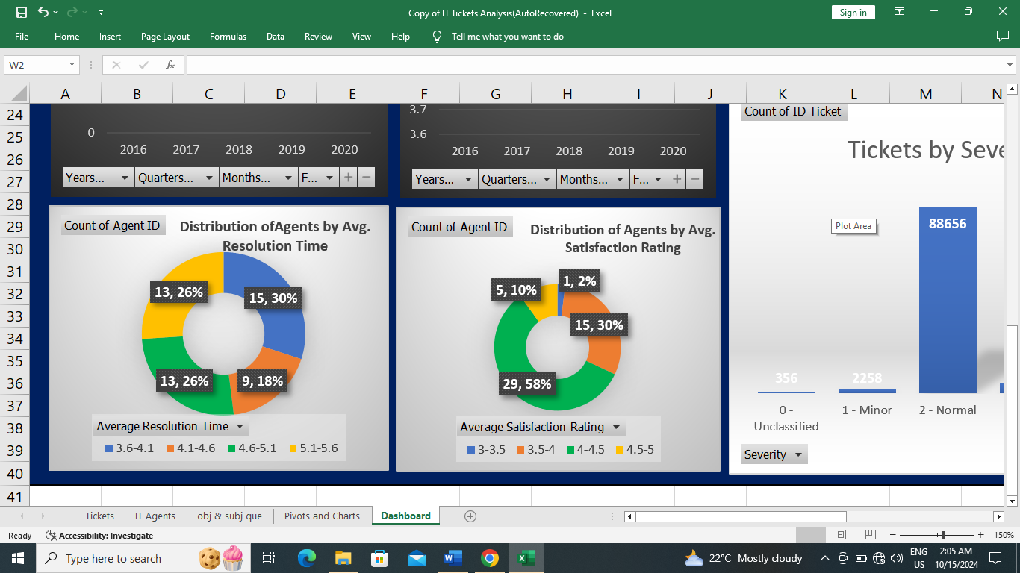

**Data Insights:**

Key performance metrics for IT agents are resolution time (days), satisfaction rate and number of tickets handled by each agent.

1. If average resolution time (4.6 days) is considered, 24 agents or 48% of them are below average.

2. If average satisfaction rate is considered (4.1), 20 agents or 40% of them are below average.

3. If average tickets handled by each agent is considered (1949), 26 agents or 52% of them are below average.

4. Highest band of average resolution time (5-5.6 days) comprises 13 agents (26%).

5. Lowest band of average resolution time (3-3.5) comprises 16 agents (32%).

**Recommendations:**

1. Firing of any agent is not recommended because there is no agent as such, who have no contribution to the team.

2. Data reveals that the team is not working at its full potential, many agents are below average values. There is ample room for training, hence training of below average agents is recommended to improve both resolution time and satisfaction rate.

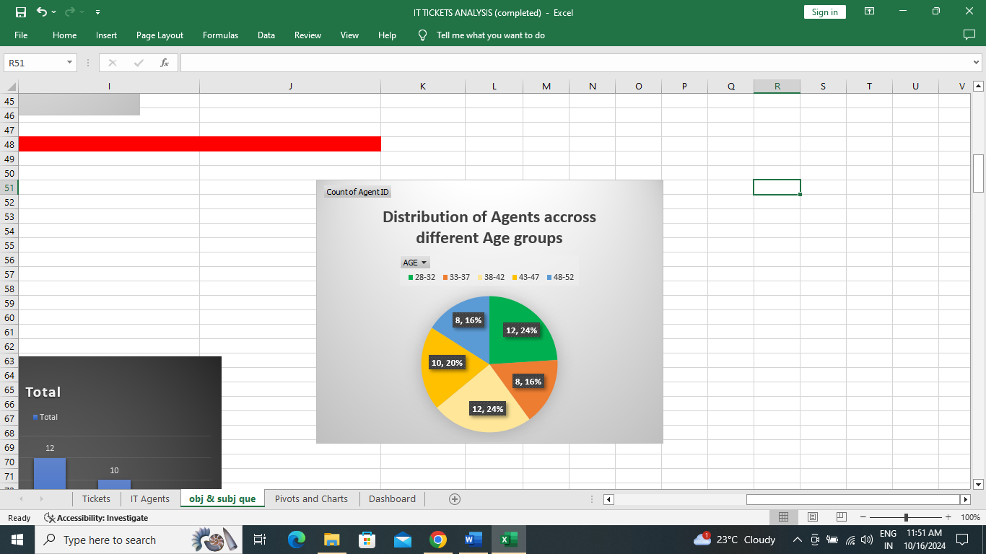**2.8** How do employee demographics (e.g., department, seniority) impact satisfaction and ticket outcomes?

ANS:

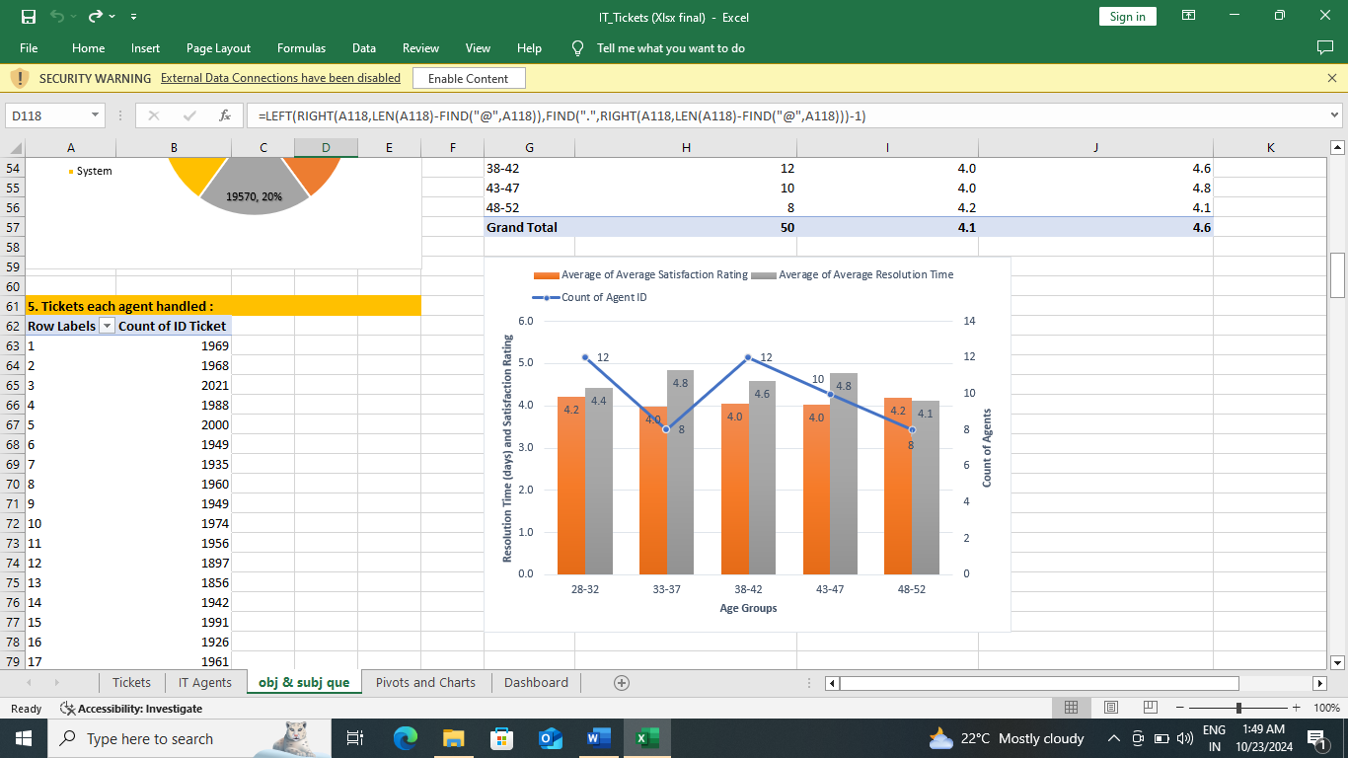

**Data Insights:**

1. There are 24% and 16% of agents in lowest age group (28-32) and highest age group (48-52). In total these two age groups make up 40% of team.

2. Remaining 60% are in between the above mentioned highest and lowest age group. That is between 33-47.

3. In terms of both average resolution time and satisfaction rating, agents of age groups 28-32 and 48-52 are outperforming the rest. Amongst these age groups agents of 48-52 have lowest resolution days.

4. Enthusiasm of juniors and experience of seniors is improving both resolution time and satisfaction rate in best. Agents in the middle age group can be brainstormed or given certain sensitive training to preform at par with seniors and juniors.

**2.9** Identify the trends for IT support operations based on ticket volumes and satisfaction, and mention the peak and stable times? (Analysis: Use pivot tables and charts to identify peak and off-peak hours.)

ANS:

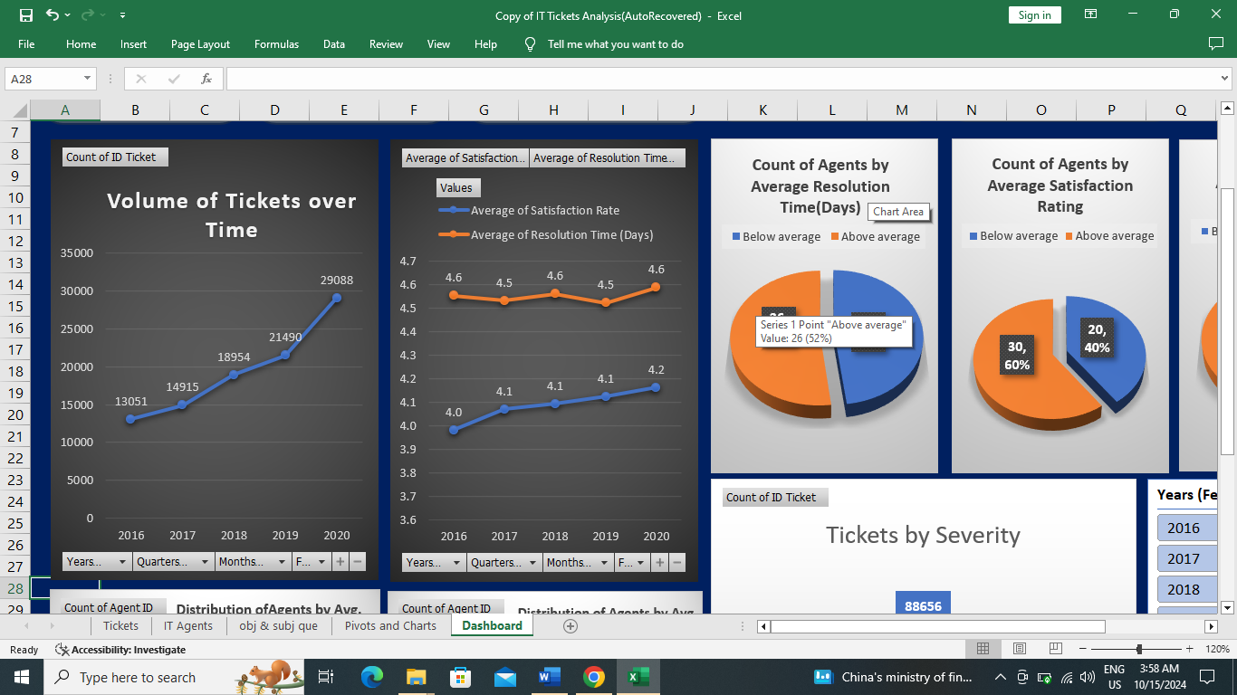

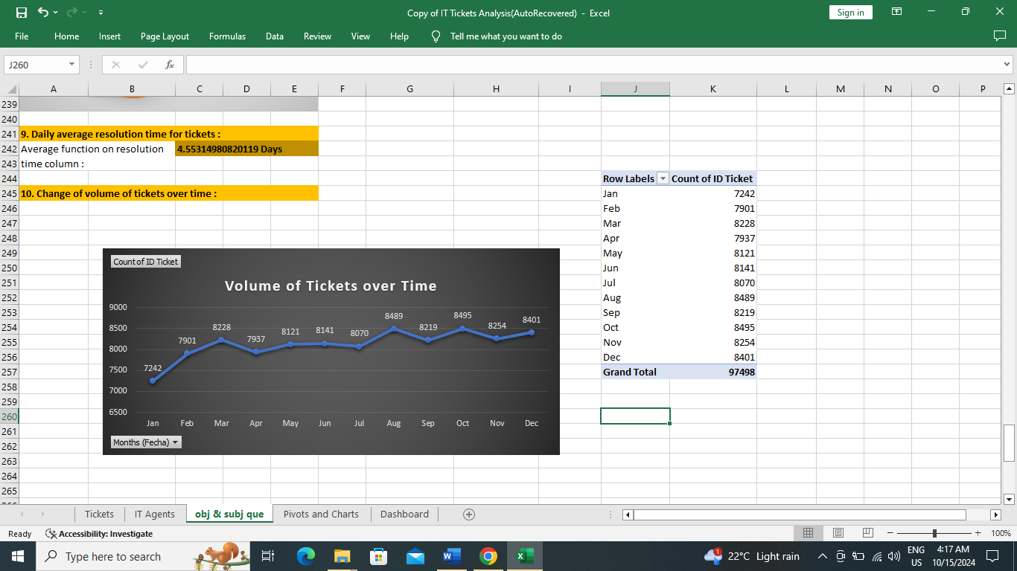

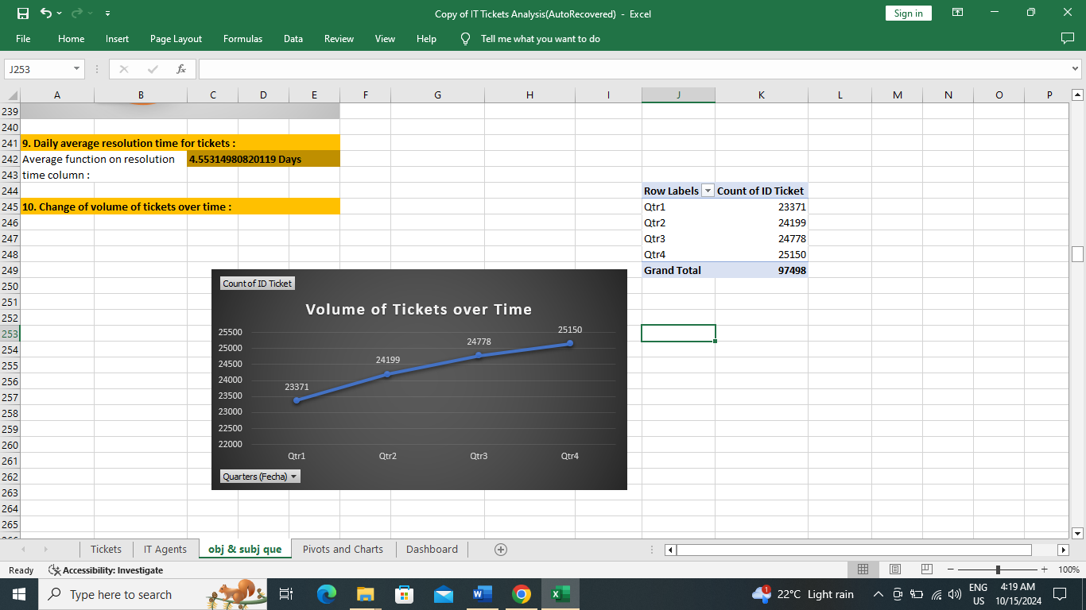

**Insights from data:**

1. Volume of tickets have increased over time.

2. Average resolution time (days) also increased from 2019 to 2020, which is a bad sign.

3. Average satisfaction rate has increased from 4.0 to 4.2 despite increasing volume of tickets, which is commendable.

4. Volume of tickets are peaked in months of August, October, December and in Quarter4 (if quarter wise data is analyzed).

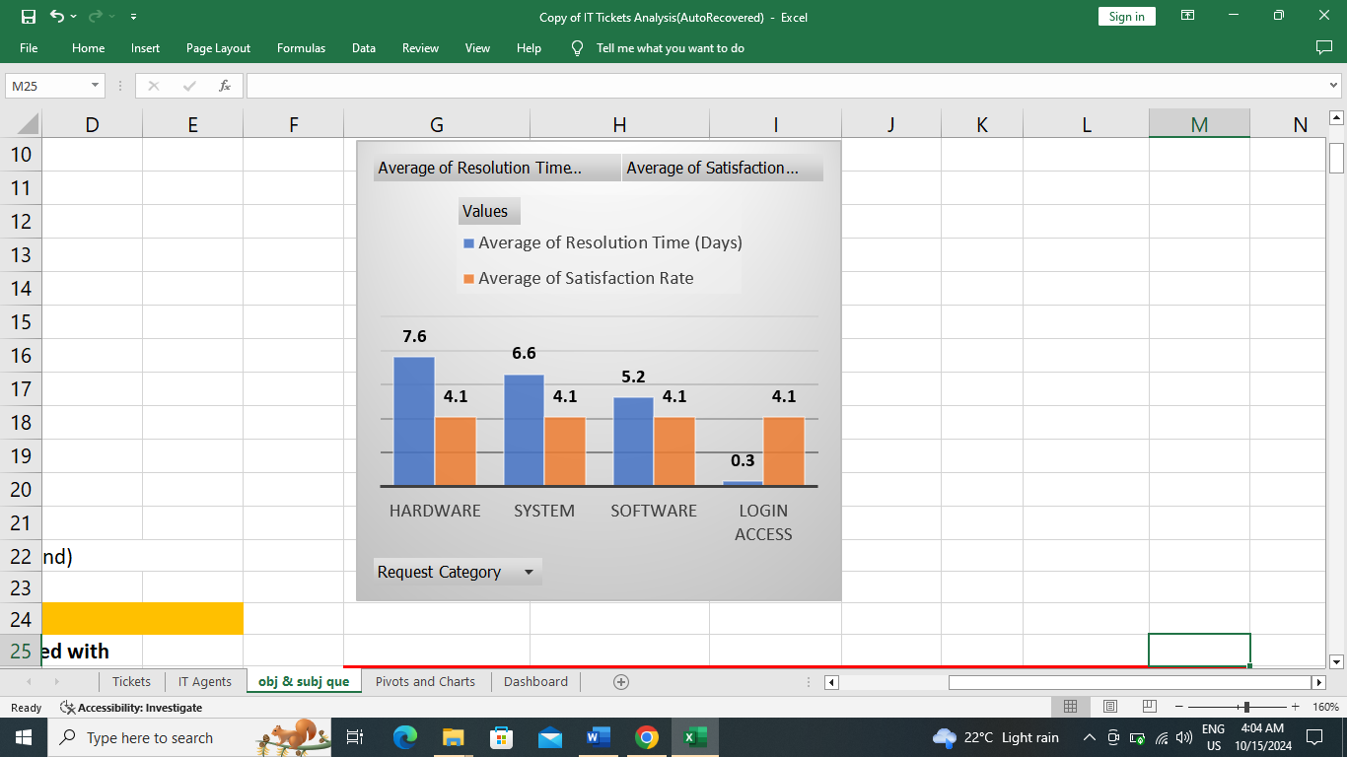**Recommendations:**

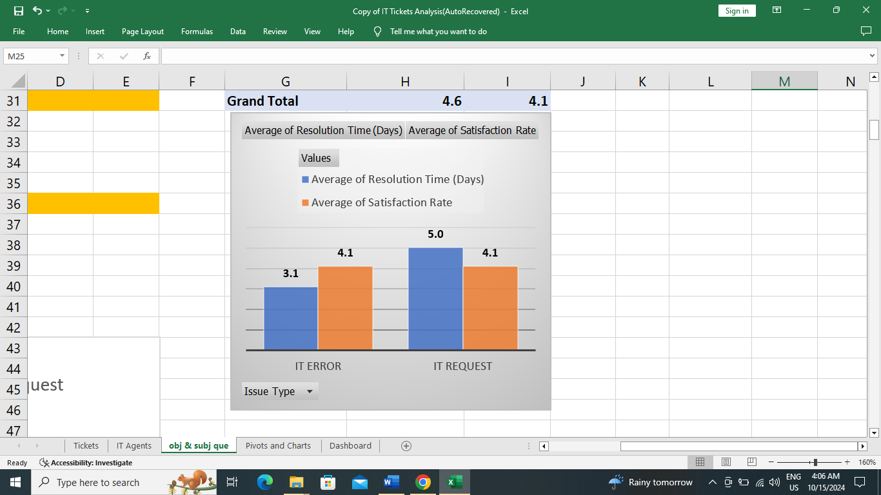

As seen from data, satisfaction rating is same for all categories and issue types, so by resolution time metric, focus must be on hardware, system and then software categories’ tickets and in issue type IT request’ tickets should be prioritized.

**2.10** What metrics should be included in the final dashboard to provide a comprehensive view of call center performance and guide investment decisions?

ANS: Dashboard’s objective is to visualize key performance metrics of agents and team as a whole and also to streamline investments to get best returns out of it.

**In that scenario metrics to be included in final dashboard:**

1. Trend analysis of Team by tickets volume, average satisfaction rating and average resolution time.

2. Analysis of percentage of agents below average or above average. To understand the gap between top performers and low performers.

3. Distribution of agents into different bands of satisfaction rating and resolution time. To select agents for the further training programs.

4. Category wise and Issue type wise number of tickets, average rating and average resolution time. To draw insights on type tickets dragging the performance of team down, so that it can be focused in future.

5. Slicers on Year, Severity, Priority and Request_category are added to enable higher management to deep dive into the data if they require.